**Functional Analysis**

**1.Job Categorization based on industries, companies and job functions.**

Use linkedin;

SELECT JI.industry_id, C.company_id, JP.job_id, C.name AS "company name", CI.industry, JS.skill_abr,

JP.title AS job_designation

FROM job_postings AS JP

INNER JOIN job_industries AS JI ON JP.job_id = JI.job_id

INNER JOIN job_skills AS JS ON JP.job_id = JS.job_id

INNER JOIN companies AS C ON C.company_id=JP.company_id

INNER JOIN company_industries AS CI ON JP.company_id=CI.company_id

ORDER BY JI.industry_id,C.company_id, JP.job_id;

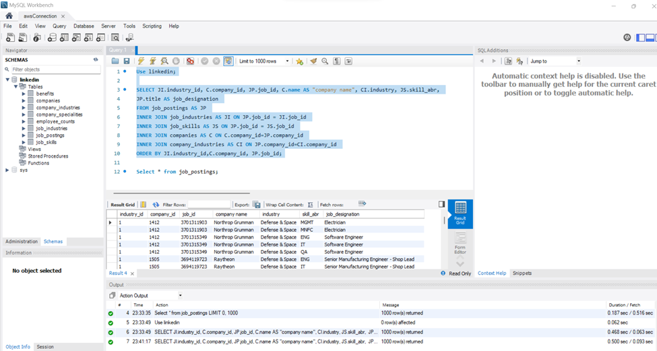

**2.Geographical distribution of Benefits and job roles provided by companies.**

SELECT C.company_id, JP.job_id, C.country, C.name AS 'company name', C.city, C.country, C.state, JP.title,

JP.formatted_experience_level, JP.work_type, B.type AS benefit_type FROM companies C

INNER JOIN job_postings AS JP ON C.company_id = JP.company_id

INNER JOIN benefits AS B ON JP.job_id = B.job_id

ORDER BY C.company_id, JP.job_id;

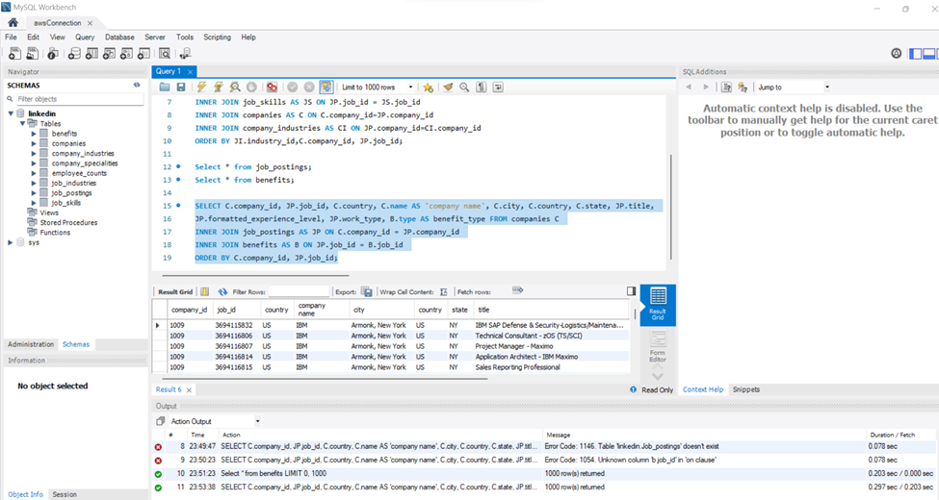

**3.Total job postings listed by each company.**

SELECT C.name AS company_name, COUNT(JP.job_id) AS job_count

FROM companies AS C

LEFT JOIN job_postings AS JP ON C.company_id = JP.company_id

GROUP BY C.name

ORDER BY job_count DESC;

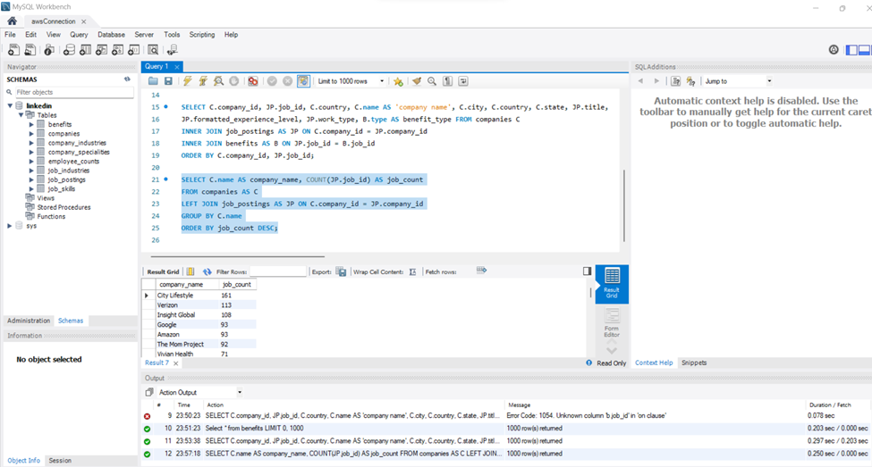

**4**. **Job posting with maximum no. of views and total number of applications**.

SELECT JP.job_id, JS.skill_abr, JP.company_id, C.name, max_views, JP.applies

FROM job_postings JP

JOIN companies C ON JP.company_id = C.company_id

JOIN job_skills JS ON JP.job_id = JS.job_id

JOIN (

SELECT MAX(views) AS max_views

FROM job_postings

) AS max_views_subquery ON JP.views = max_views_subquery.max_views

JOIN (

SELECT job_id, SUM(applies) AS applies

FROM job_postings

GROUP BY job_id

) AS applies_subquery ON JP.job_id = applies_subquery.job_id;

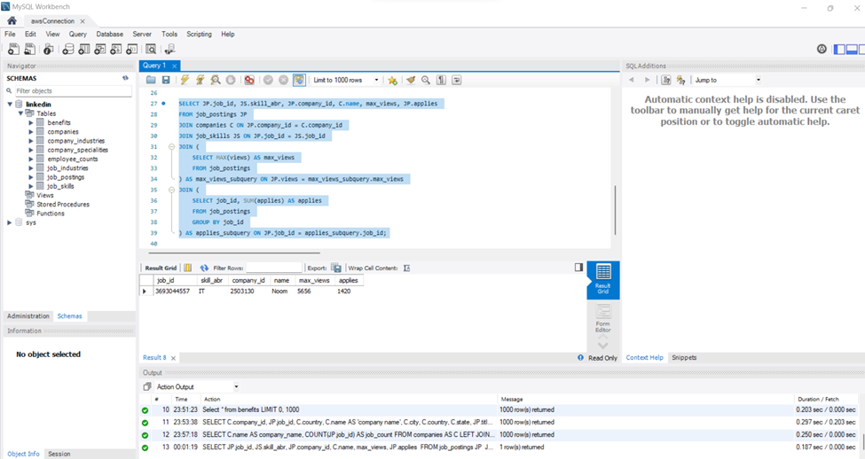

**5.Identifying skills in demand**.

SELECT skill_abr, COUNT(skill_abr) AS skill_count

FROM job_skills

GROUP BY skill_abr

ORDER BY skill_count DESC;

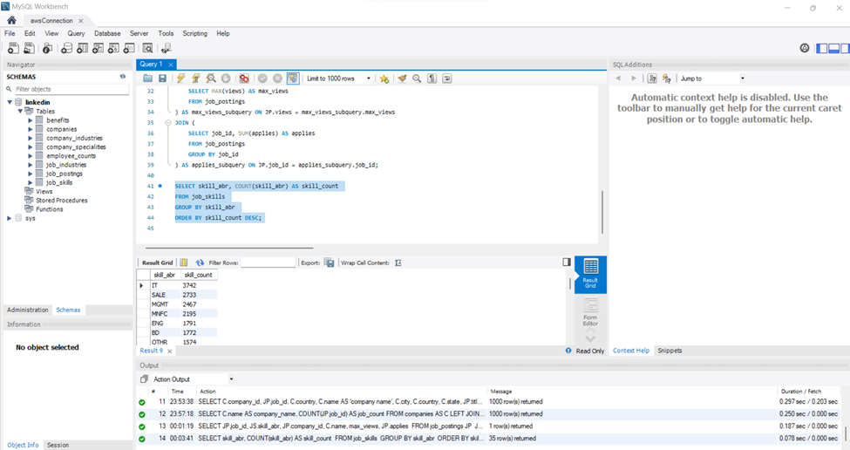

**6**. **Company having highest employee count.**

SELECT EC.company_id, C.name, MAX(EC.employee_count) AS highest_employee_count

FROM employee_counts EC

INNER JOIN companies AS C ON C.company_id=EC.company_id

GROUP BY EC.company_id, C.name

ORDER BY highest_employee_count desc

LIMIT 1;

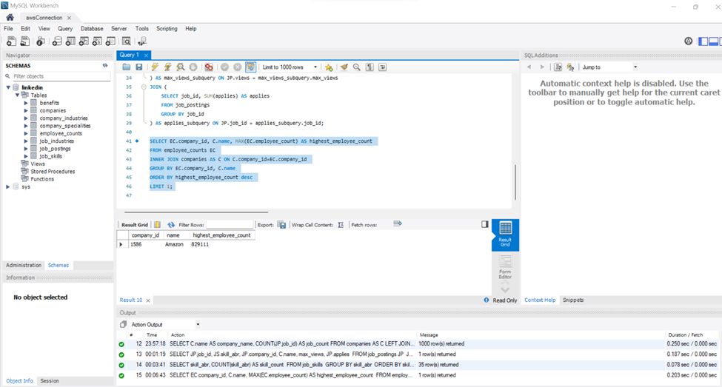

**7. Job postings that are currently active, not expired or closed.**

SELECT job_id, company_id, title, work_type, pay_period, compensation_type, listed_time, expiry, closed_time, job_posting_url, application_url

FROM linkedin.job_postings

WHERE job_id NOT IN (

SELECT job_id

FROM linkedin.job_postings

WHERE closed_time < CURRENT_TIMESTAMP()

OR expiry < CURRENT_TIMESTAMP()

);

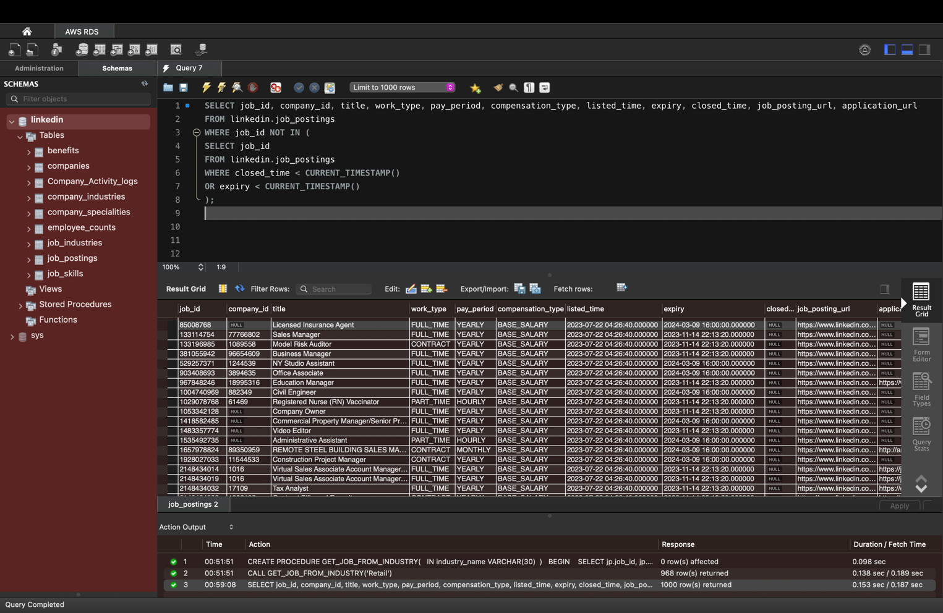

8.**Location wise top 10 companies with the most job postings**

SELECT j.company_id, c.name AS company_name, COUNT(*) AS job_posting_count, location, j.title,

j.med_salary

FROM job_postings AS j

JOIN companies AS c ON j.company_id = c.company_id

where j.med_salary != "NULL"

GROUP BY j.company_id, company_name, j.title, location, j.med_salary

ORDER BY COUNT(*) DESC

LIMIT 10;

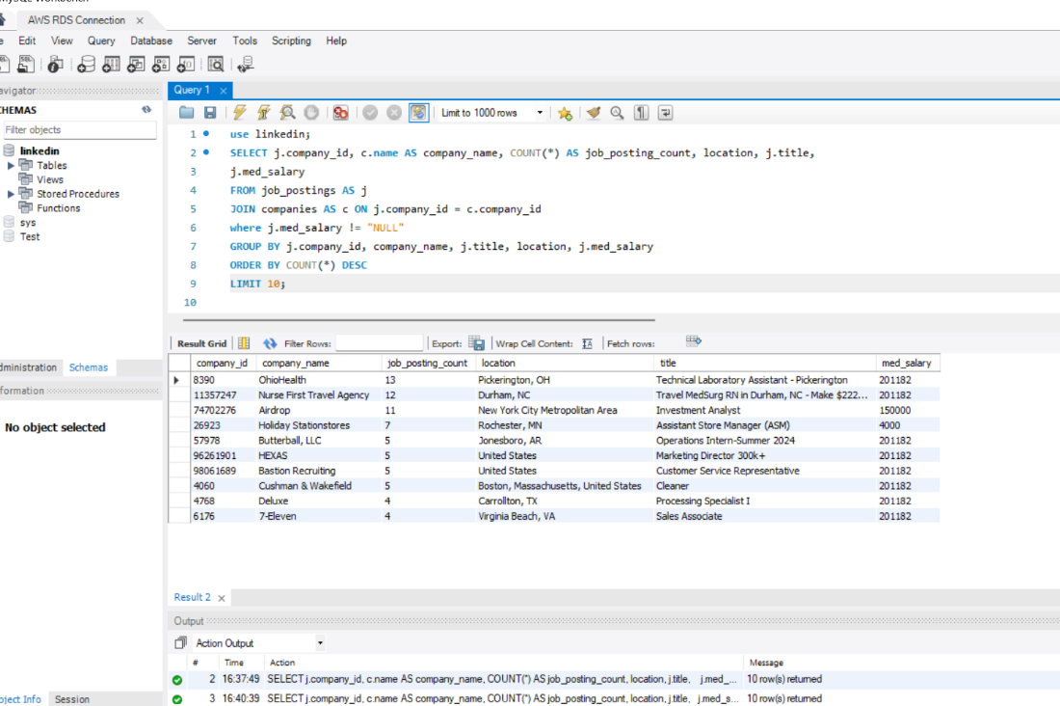

9. **Analysis of Job Postings with on Location, Company, Title, and Application Duration and filtered through Inferred through text by linkedin**

SELECT j.job_id,j.location, c.name, j.title, datediff(expiry,listed_time) as Days_to_apply

FROM job_postings_old AS j

JOIN companies AS c ON j.company_id = c.company_id

JOIN benefits AS jben

ON j.job_id = jben.job_id

where jben.inferred = 1

ORDER BY j.location,j.closed_time DESC, j.max_salary DESC;

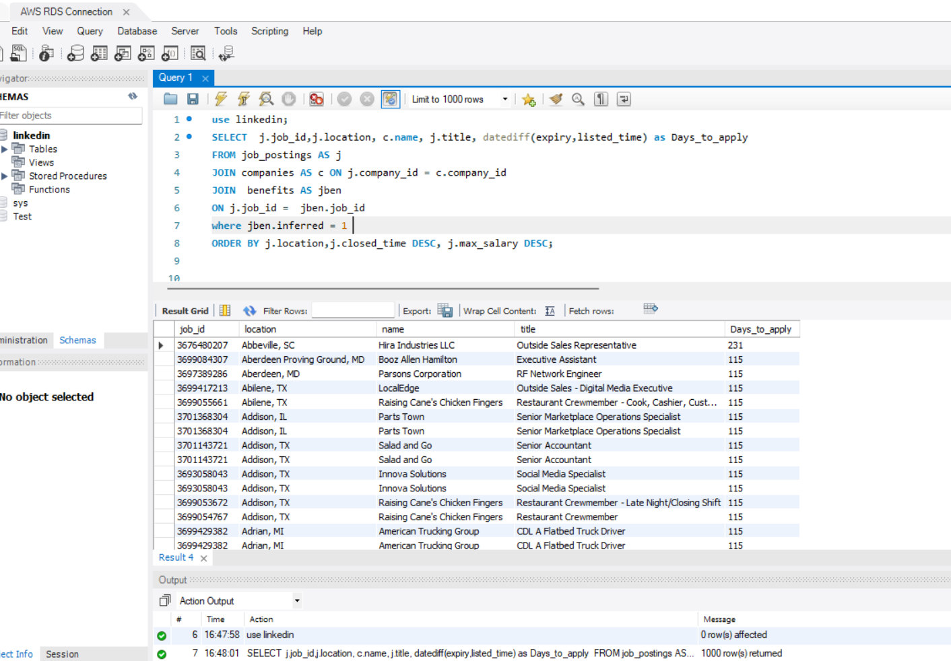

10. **Companies and their competitors sharing the same industry**

SELECT

ci1.company_id AS company_id,

ci2.company_id AS competitor_company_id,

c1.name AS company_name,

c2.name AS competitor_company_name,

ci1.industry AS shared_industry

FROM company_industries AS ci1

JOIN company_industries AS ci2 ON ci1.industry = ci2.industry AND ci1.company_id < ci2.company_id

JOIN companies AS c1 ON ci1.company_id = c1.company_id

JOIN companies AS c2 ON ci2.company_id = c2.company_id;

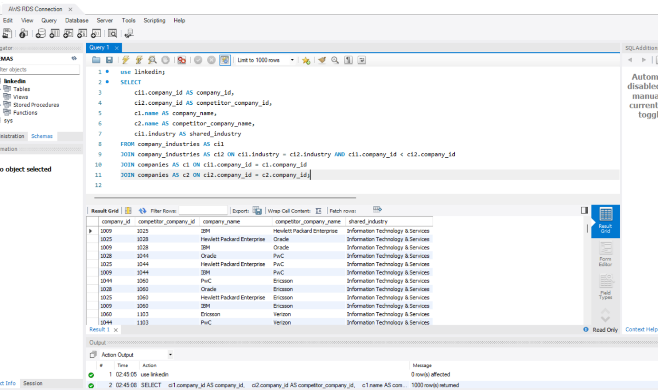

**11. Analyze Job Demand Over month:**

SELECT

Month(expiry) AS month, SUM(views) AS total_views,

COUNT(*) AS job_count

FROM job_postings_old

GROUP BY month

ORDER BY month;

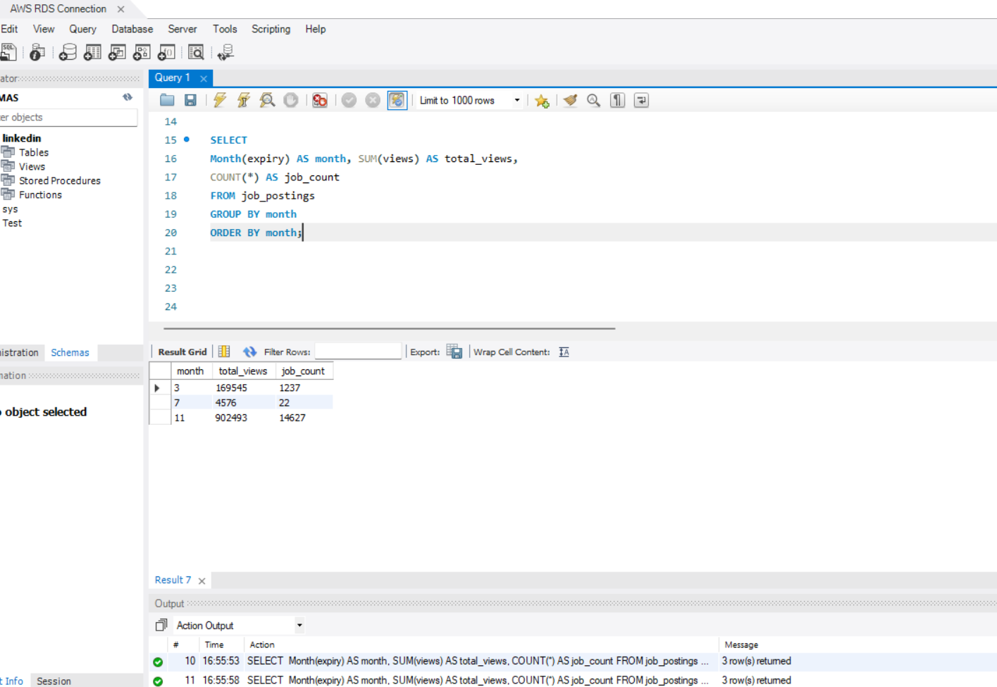

**12. Partition Method to get the Annual salary on the max_salary specifying range in where clause.**

SELECT

j.company_id,

j.formatted_work_type,

j.pay_period,

j.max_salary AS max_salary,

max(round(j.max_salary * 12, 3)) OVER (PARTITION BY j.company_id) AS Annual_Salary

FROM job_postings j

where (company_id BETWEEN 1500 AND 2500) and pay_period ='MONTHLY';

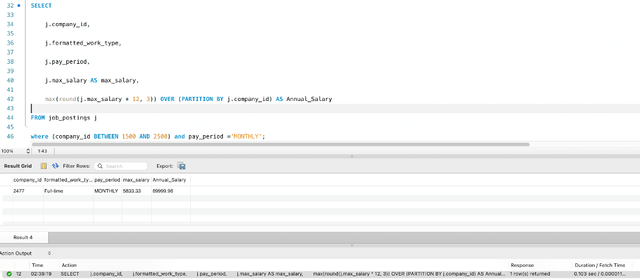

**13. Analyzing the count of different work types such as Full-Time, Part-Time and Contractor Roles based on their pay_period**

SELECT

pay_period,

sum(formatted_work_type = 'Full-time') AS "Full-Time Roles",

sum(formatted_work_type = 'Part-time') AS "Part-Time Roles",

sum(formatted_work_type = 'Contract') AS "Contract Roles"

FROM job_postings

GROUP BY pay_period

ORDER BY pay_period;

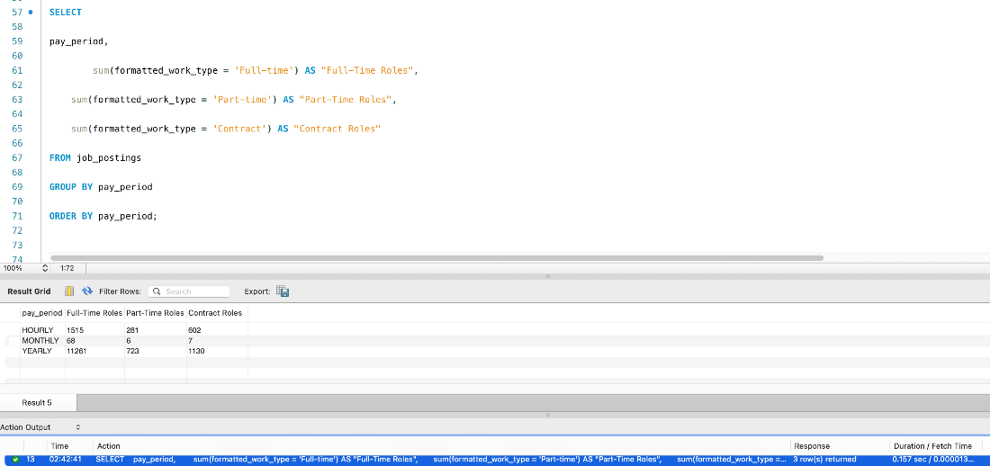

**14. Analyzing the number of Full-Time opportunities offered for Monthly pay_period by each company**

SELECT

company_id,

pay_period,

COUNT(formatted_work_type) AS "Total Full-Time Roles"

FROM job_postings

WHERE formatted_work_type = 'Full-time' and pay_period= 'MONTHLY'

GROUP BY company_id

ORDER BY company_id;

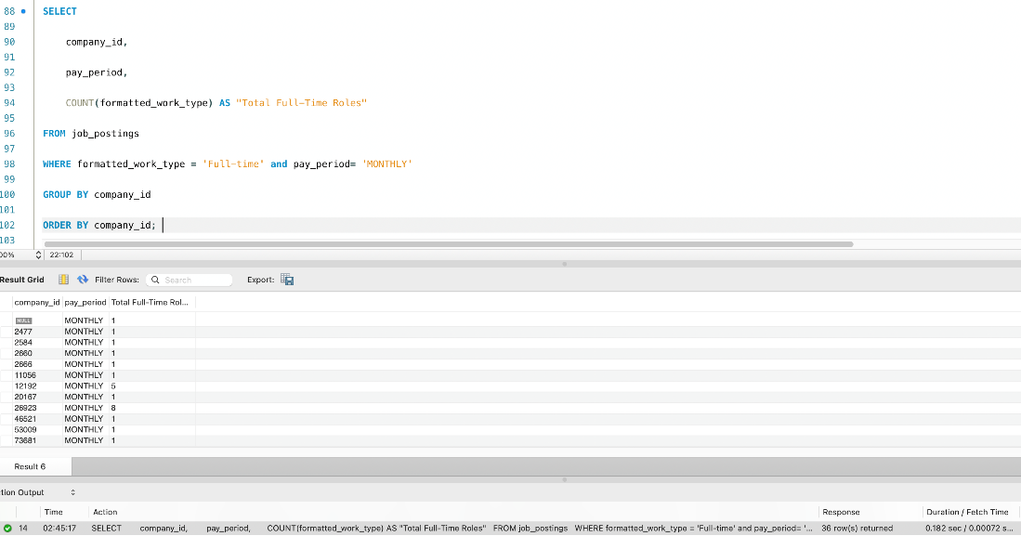

**15. Display the Total Roles in each roles types by every company.**

SELECT

company_id,

formatted_work_type,

pay_period,

COUNT(*) OVER (PARTITION BY company_id ORDER BY pay_period) AS "Total Roles"

FROM job_postings

WHERE pay_period != 'NA' and company_id != 0

ORDER BY pay_period;

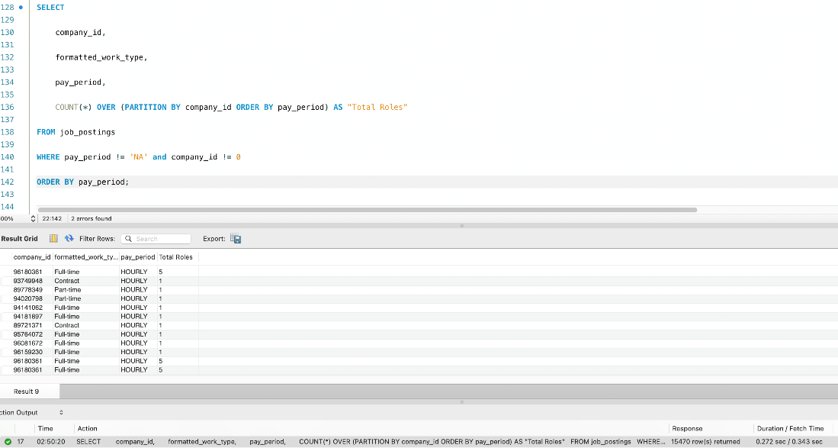

**16. Partition Method to get the Annual salary on the max_salary specifying range in where clause.**

SELECT

j.company_id,

j.formatted_work_type,

j.pay_period,

j.max_salary AS max_salary,

max(round(j.max_salary * 12, 3)) OVER (PARTITION BY j.company_id) AS Annual_Salary

FROM job_postings j

where (company_id BETWEEN 1500 AND 2500) and pay_period ='MONTHLY';

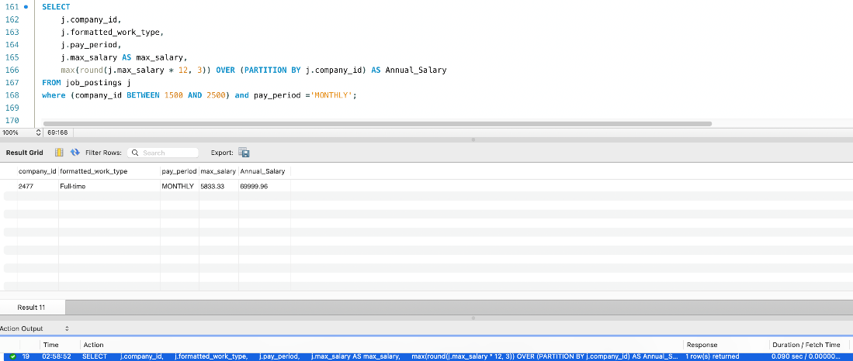

**STORED PROCEDURES:**

1. **Companies with vision Insurance as benefit**

DELIMITER //

CREATE PROCEDURE GetCompanieswithspecificBenefit(BenefitType VARCHAR(100))

BEGIN

SELECT DISTINCT j.job_id, c.name AS company_name

FROM job_postings AS j

join companies as c on c.company_id = j.company_id

JOIN benefits AS b ON j.job_id = b.job_id

WHERE b.type = BenefitType;

END;

//

DELIMITER ;

call GetCompanieswithspecificBenefit('Vision insurance');

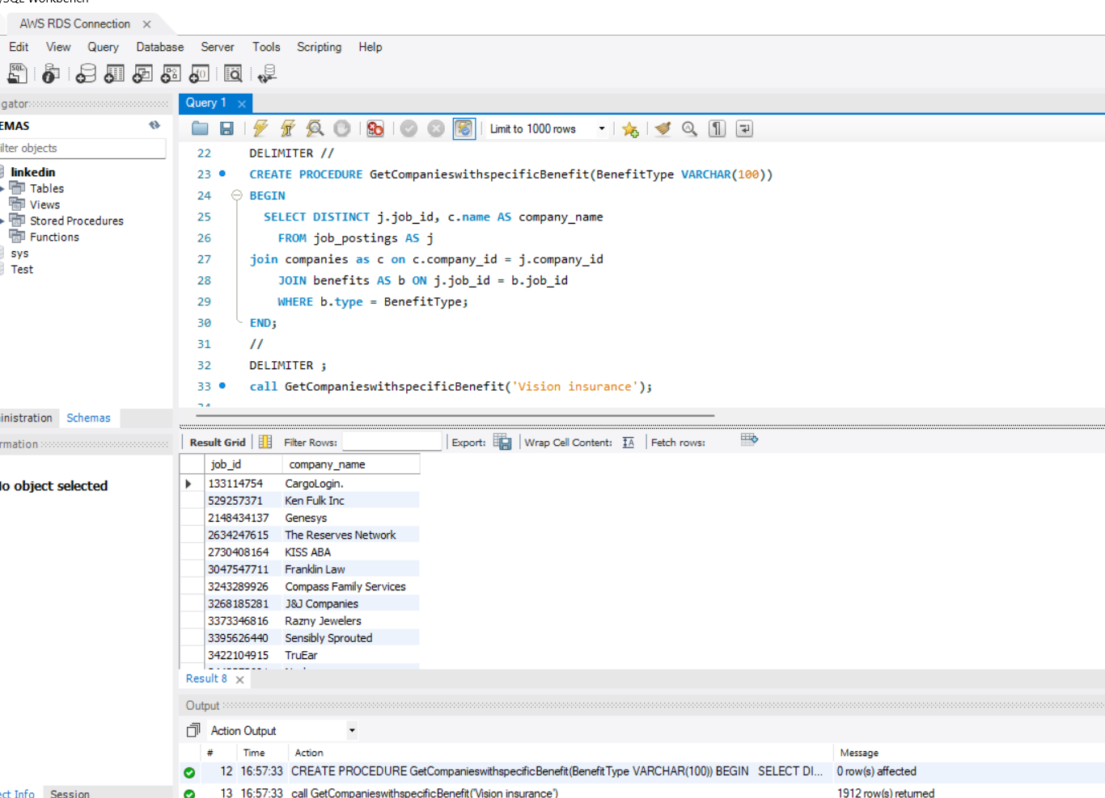

1. **Analysing Industry wise employee count**

DELIMITER //

CREATE PROCEDURE CalculateEmployeeCountByIndustry()

BEGIN

SELECT ci.industry, c.name, ec.employee_count

FROM company_industries AS ci

INNER JOIN companies AS c on ci.company_id =c.company_id

INNER JOIN employee_counts AS ec ON ci.company_id = ec.company_id

GROUP BY ci.industry, c.name,ec.employee_count ;

END;

//

DELIMITER ;

call CalculateEmployeeCountByIndustry();

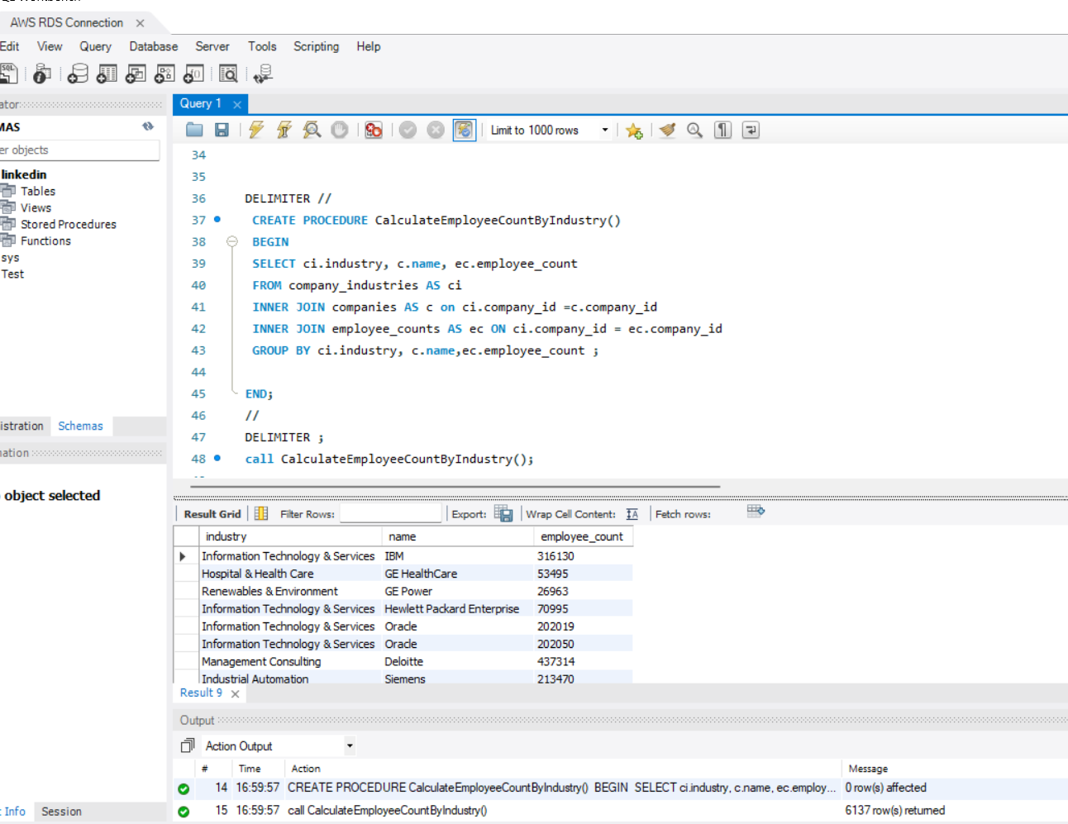

1. **Get Job Postings With Metrics by Company Size for given type of work**

DELIMITER //

CREATE PROCEDURE GetJobPostingsWithMetricsAndSortByCompanySize(type_of_work VARCHAR(100))

BEGIN

SELECT jp.job_id,c.name AS company_name, jp.title, jp.description, jp.pay_period,

jp.work_type,

c.company_size

FROM job_postings AS jp

INNER JOIN companies AS c ON jp.company_id = c.company_id

where jp.work_type = type_of_work

ORDER BY c.company_size desc;

END;

//

DELIMITER ;

call GetJobPostingsWithMetricsAndSortByCompanySize('PART_TIME');

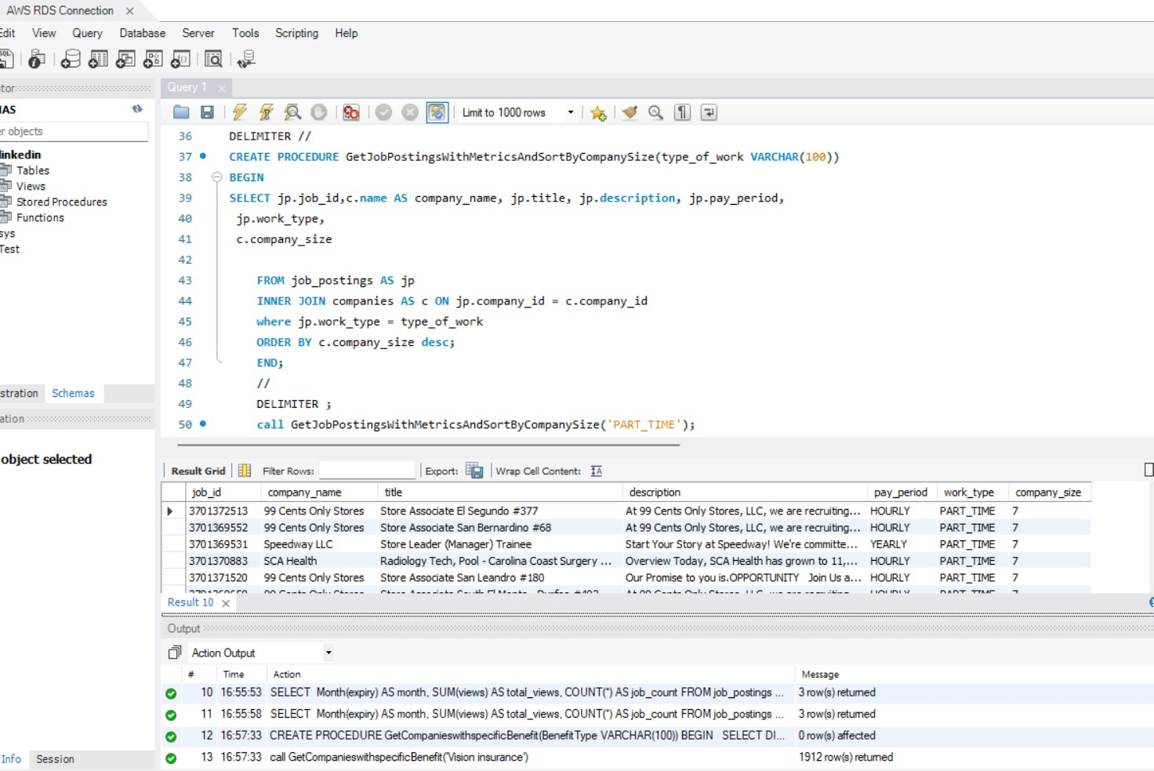

1. **Find all jobs from a particular industry**

DELIMITER $$

CREATE PROCEDURE GET_JOB_FROM_INDUSTRY(

IN industry_name VARCHAR(30))

BEGIN

SELECT jp.job_id, jp.company_id, jp.title, jp.work_type, jp.location, jp.expiry, jp.closed_time, jp.posting_domain, jp.job_posting_url, jp.application_url

FROM linkedin.job_postings AS jp

JOIN linkedin.company_industries AS ci

ON jp.company_id = ci.company_id

WHERE ci.industry = industry_name;

END $$

DELIMITER ;

CALL GET_JOB_FROM_INDUSTRY('Retail');

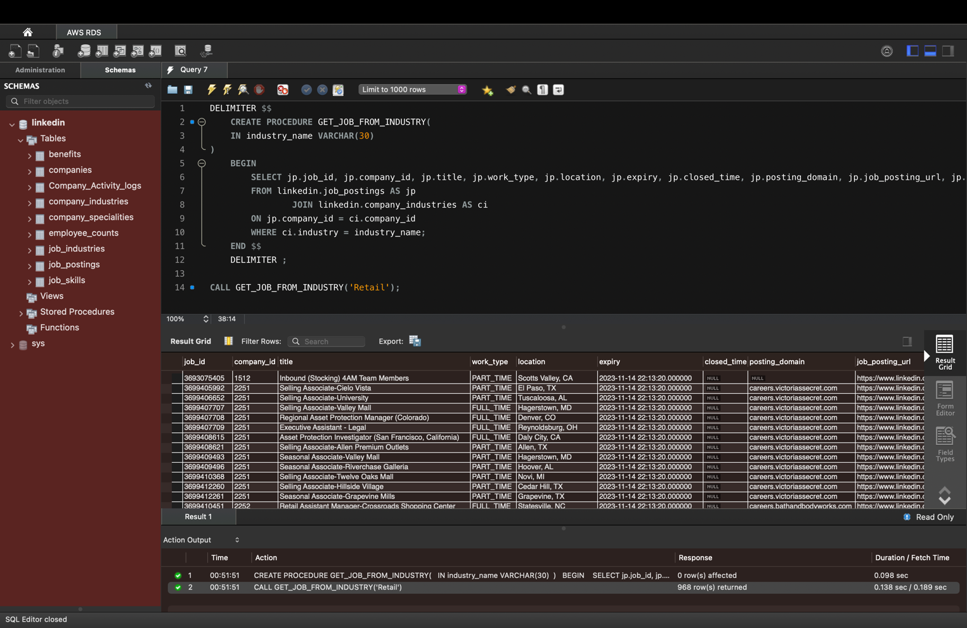

1. **Display companies offering remote work.**

DELIMITER //

CREATE PROCEDURE GetRemoteJobs()

BEGIN

SELECT DISTINCT C.name AS 'company name', JP.location, JP.title, JP.job_id

FROM companies C

INNER JOIN job_postings JP ON C.company_id = JP.company_id

WHERE JP.remote_allowed = 1;

END;

//

DELIMITER ;

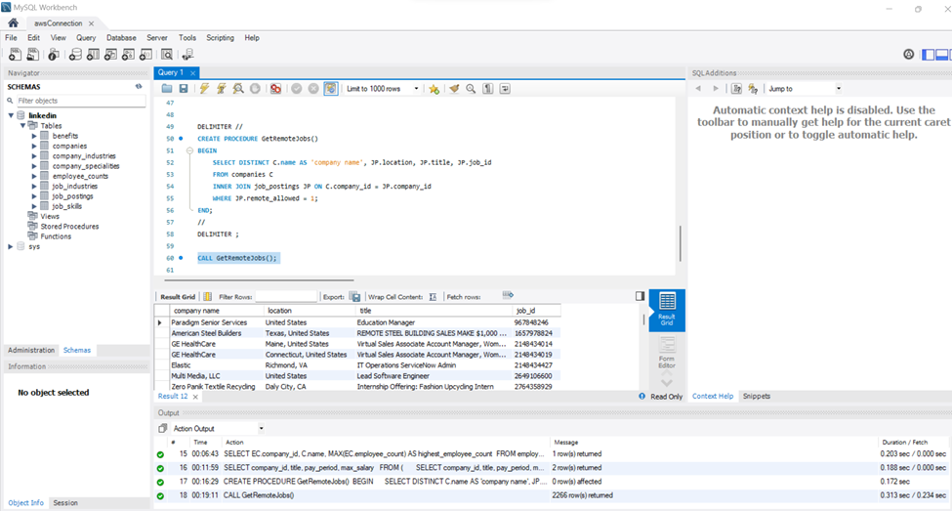

1. **Procedure to insert values to companies and company_specialities table and get the latest count of total specialities with its corresponding company_id.**

DELIMITER //

CREATE PROCEDURE ProcessCompanySpecialitiesWithDeduplicateCompanyID(

IN p_company_id BIGINT,

IN p_speciality VARCHAR(256))

BEGIN

INSERT INTO company_specialities (company_id, speciality)

VALUES (p_company_id, p_speciality)

ON DUPLICATE KEY UPDATE speciality = p_speciality;

SELECT company_id, COUNT(*) AS total_specialities

FROM company_specialities

WHERE company_id = p_company_id

GROUP BY company_id;

END //

DELIMITER ;

**Calling the function:**

call ProcessCompanySpecialitiesWithDeduplicateCompanyID(999999999,'ZZZ 22 TEST Speciality');

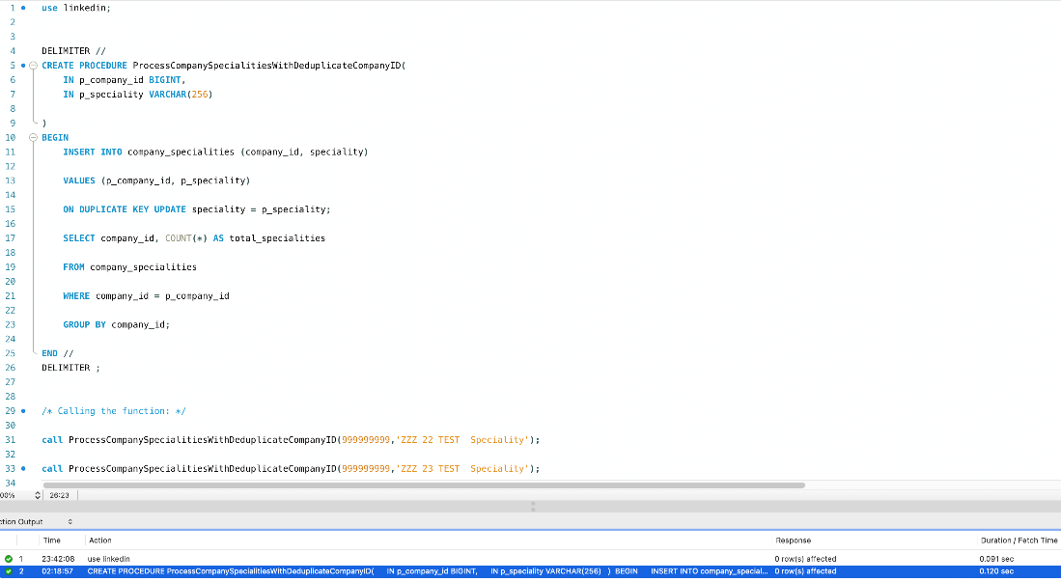

1. ***Procedure to get the exact user desired count as total_specialities_param to produce the company_id, speciality and total_specialities***

DELIMITER //

CREATE PROCEDURE GetTotalSpecialities(total_specialities_param int)

BEGIN

select * from (

SELECT *,

COUNT(*) OVER (PARTITION BY company_id) AS total_specialities

FROM company_specialities

order by (COUNT(*) OVER (PARTITION BY company_id)) desc

) A

where total_specialities =total_specialities_param;

END;

// DELIMITER ;

**Calling the function:**

call GetTotalSpecialities(20);

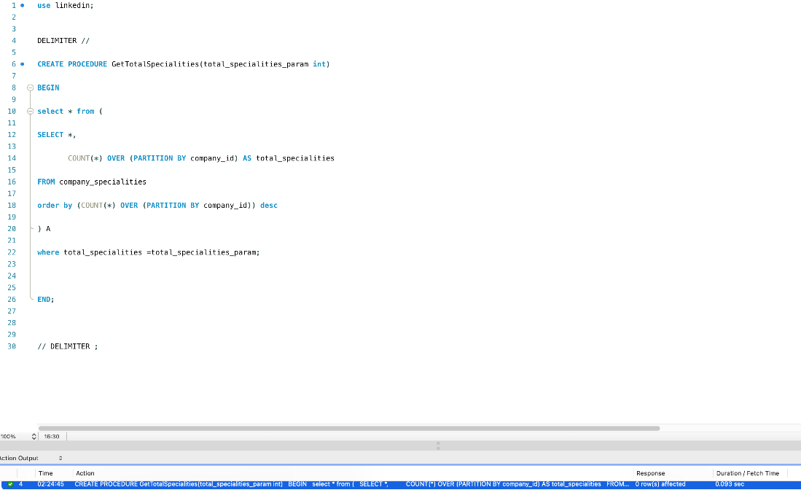

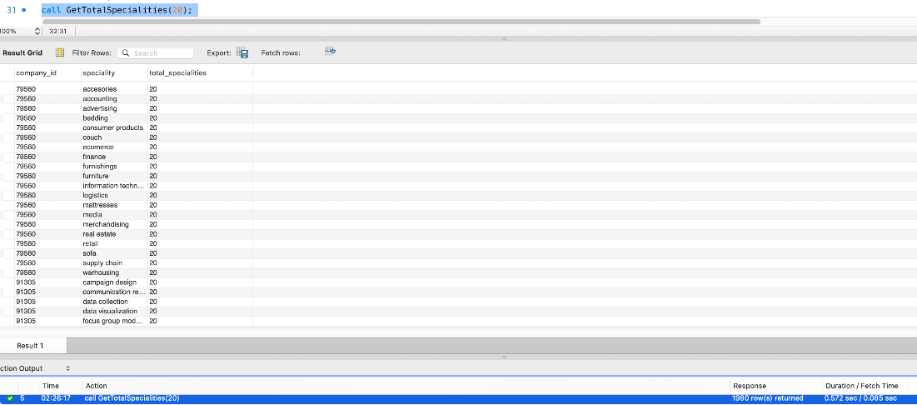

**TRIGGERS:**

1. **Inserting value in Company activity log table after a deletion of company in companies table**

DELIMITER $$

CREATE TRIGGER Delete_job_posting_with_company

AFTER DELETE ON Companies FOR EACH ROW

BEGIN

UPDATE job_postings SET Company_id = NULL WHERE company_id = old.company_id;

INSERT INTO Company_Activity_logs VALUES ( old.Company_id, CONCAT('Row has been deleted from Job_postings for comapny ', old.Company_id));

END $$

DELIMITER ;

**2 Creating a trigger to log changes to the job_postings table**

DELIMITER //

CREATE TRIGGER JobPostingsAuditTrigger

AFTER UPDATE ON job_postings FOR EACH ROW

BEGIN

INSERT INTO job_postings_audit (job_id, updated_column, old_value, new_value)

VALUES (OLD.job_id, 'title', OLD.title, NEW.title);

INSERT INTO job_postings_audit (job_id, updated_column, old_value, new_value)

VALUES (OLD.job_id, 'work_type', OLD.work_type, NEW.work_type);

INSERT INTO job_postings_audit (job_id, updated_column, old_value, new_value)

VALUES (OLD.job_id, 'location', OLD.location, NEW.location);

END;

//

DELIMITER ;

UPDATE job_postings

SET title = 'Sales Manager', work_type ='FULL_TIME', location = 'Santa Clarita'

WHERE job_id = 133114754;

SELECT * FROM job_postings_audit;

